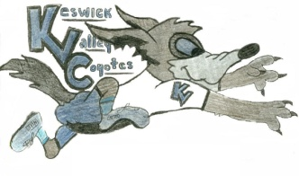KVMS April 27th to May 1st Activity Challenge
What is it?
Track your Physical Activity each day Monday through Friday this week and email crystal.bourgoin@nbed.nb.ca at the end of the week with your complete tracker. If your class is on teams you can send it to me that way too. A prize will be drawn!
What is a tracker?
The day, activity you choose to stay active and the amount of time you spend doing it. Please fill out each day for 5 days. This helps you track how active you are. Remember to get your heart rate up for 30mins.
Below is what I did last week:
This is just an example and what I like to do to move. Pick things you enjoy doing. I have shared several activities on the Athletics page, Teams and have emailed homeroom teachers examples for you to try. Feel free to get creative as well (create your own obstacle course, create a new game with a ball or socks, play your fav sport with a sibling etc). My daughters and I are creating a ninja warrior course in our yard next week. I cannot wait!
Mrs. Bourgoin’s Week 1 of Activity Tracker:
Monday: walk/jog 45mins
Tuesday: Bike 30mins
Wednesday: Cleaning 30minutes (sweeping, mopping, yard work)
Thursday: Walking 45mins
Friday: 1 hour 15minutes walk 1km run sprints and walk 9kms
Feel free to email me: crystal.bourgoin@nbed.nb.ca

